ASME Dynamic Systems and Control Division (DSCD)

Awards Ceremony and Oldenburger Lecture

2023 Modeling, Estimation and Control Conference

October 4th, 2023, 11:35 am - 1:50 pm
Event Floor of the Tahoe Blue Event Center, Lake Tahoe, Nevada

Program:

Welcome
Jingang Yi, DSCD Chair
Presentation of Awards
Roberto Horowitz, DSCD Honors & Awards Committee Chair
DSCD Awards
Yasundo Takahashi Education Award
Outstanding Young Investigator Award
Rudolf Kalman Best Paper Award
Nyquist Lecturer
Rufus T. Oldenburger Medal & Lecture

2023 Rufus T. Oldenburger Medalist

Davor Hrovat
Adjunct Distinguished Professor
MAE Department, University of California San Diego

Citation:

For outstanding contributions and technical leadership in applying modeling and control systems principles to the practice of automotive and aerospace engineering resulting in improved safety and performance of millions of vehicles and thousands of commercial aircraft worldwide.
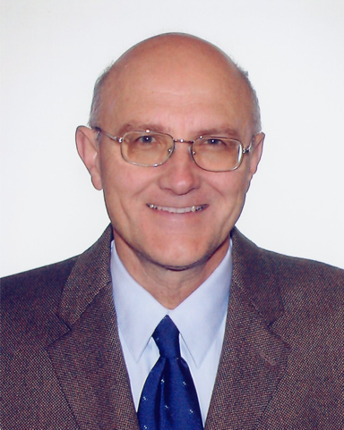
Dr. Davor Hrovat received his Dipl. Ing. degree in mechanical engineering from the University of Zagreb in 1972, and his M.S. and Ph.D. degrees in mechanical engineering from the University of California, Davis in 1976 and 1979, respectively. From 1981-2015, he was with the Ford Motor Company where he conducted and led R&D efforts on various aspects of chassis, power train and overall vehicle control. He holds more than 100 US patents and is the author/co-author of more than 150 technical papers and propitiatory reports. Many of his patents have been used in production to improve efficiency, performance, comfort and safety of millions of vehicles.

During 1999-2000 he was an invited member of the Boeing 737 Engineering Test Evaluation Board (ETEB) consisting of about 20 top engineering experts chosen to perform “fresh eye” evaluation of Boeing 737 safety. Dr Hrovat contributed to this important effort through insightful analysis and innovative sensor schemes that were deemed not possible in the past.

In 2006 he was appointed the first Henry Ford Technical Fellow in the area of Controls. This is the highest technical recognition in the Company and to date there have been only 16 Technical Fellows since program inception almost 30 years ago.
2023 Rufus T. Oldenburger Lecture

October 4th, 2023, 11:35 am - 1:50 pm
Event Floor of the Tahoe Blue Event Center, Lake Tahoe, Nevada

Automotive Computer Control Systems:
Looking Back (and Peeking Forward) at Key Developments from the Perspective of an Industrial Researcher

Davor Hrovat
Adjunct Distinguished Professor
MAE Department, University of California San Diego

Abstract

In this talk I will try to survey developments in automotive computer control systems during the past three or four decades, which incidentally and fortuitously coincided with my career in this exciting and challenging field. Starting in late 70s and early 80s with just dozens or at most hundreds of lines of assembly code, the field saw an exponential growth so that that by the time I retired in 2015 typical cars had dozens of processors with hundreds of thousands if not millions of lines of C code and similar constructs.

During the talk, I will intertwine my personal experiences with some general facts, many of them focused around Ford, a company where I spent most of my career. I hope that in the process we will 1) acquire additional insight about some very common vehicle components and subsystems, and, 2) clarify some of the misconceptions (and hopefully in the process not create new ones) about this still very dynamic and active field. I will also venture some personal observations about present and future related developments and major pushes, such as EVs, AVs and other Vs, for example.
2023 Yasundo Takahashi Education Award

Professor Richard C. Hill
Professor of Mechanical Engineering
Assistant Dean for Research and External Initiatives, COE
University of Detroit Mercy

Citation:

For outstanding contributions in the development of pedagogical materials and on-line tools that advance student engagement and learning in the areas of dynamic systems and control, and significant contributions to providing accessible pathways and strong preparation to STEM disciplines for underrepresented and underserved students in the metro-Detroit region and beyond.

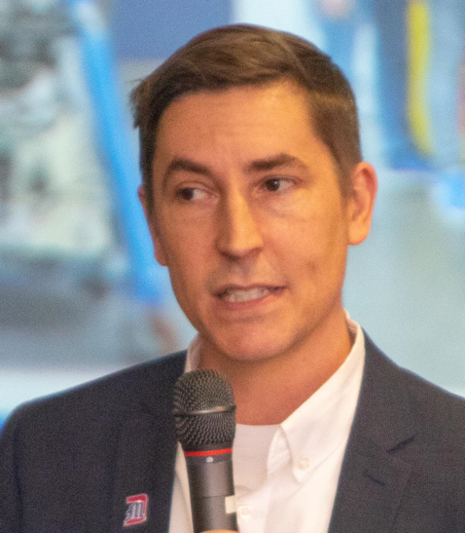
Richard C. Hill is a Professor of Mechanical Engineering and the Assistant Dean for Research and External Initiatives in the College of Engineering & Science at University of Detroit Mercy. Dr. Hill received the B.S. degree in Mechanical Engineering, summa cum laude, from the University of Southern California in 1998, and the M.S. degree in Mechanical Engineering from the University of California, Berkeley in 2000. From 2000 to 2002, he worked at Lockheed Martin Corporation on satellite attitude determination and control. He then spent two years as a high school math and science teacher. In 2008 he received the Ph.D. degree in Mechanical Engineering and the M.S. degree in Applied Mathematics from the University of Michigan, Ann Arbor. In 2008 Dr. Hill joined the faculty of the Mechanical Engineering Department at Detroit Mercy. His research focuses on scaling and optimizing supervisory control logic for complex discrete-event systems through modular and hierarchical techniques. Dr. Hill also has an interest in vehicle control applications, engineering education, and diversifying the STEM pipeline through his leadership of the iDRAW high school STEM pathways program and SEED Scholars program at Detroit Mercy.

2023 Young Investigator Award

Neera Jain
Associate Professor of Mechanical Engineering
School of Mechanical Engineering
Purdue University

Citation:

For outstanding contributions in the control of transient thermal systems using the second law of thermodynamics in a feedback optimization framework, and the formulation of control co-design and human-autonomy teaming design techniques.

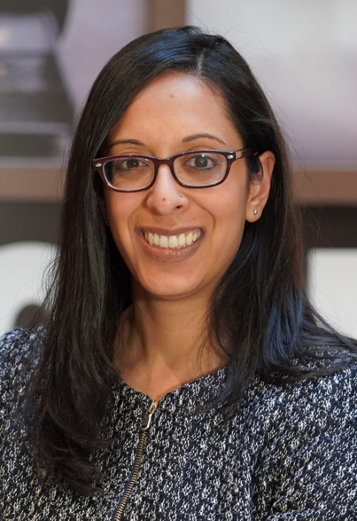
Neera Jain is an Associate Professor in the School of Mechanical Engineering and a faculty member in the Ray W. Herrick Laboratories at Purdue University. She earned her M.S. and Ph.D. degrees in mechanical engineering from the University of Illinois at Urbana-Champaign in 2009 and 2013, respectively, and earned her S.B. from the Massachusetts Institute of Technology in 2006. She has held visiting research positions at Mitsubishi Electric Research Laboratories, Air Force Research Laboratory (AFRL) at Wright-Patterson Air Force Base (AFB) (Aerospace Systems Directorate) and AFRL at Kirtland AFB (Space Vehicles Directorate). Her research has been supported by the National Science Foundation, Air Force Research Laboratory, Office of Naval Research, as well as private industry, disseminated in over 50 peer-reviewed manuscripts, and translated to industry in multiple patents. She is the recipient of the 2022 NSF CAREER Award, a National Research Council (NRC) Research Associateship Award and was invited to participate in the 2022 EU-US Frontiers of Engineering Symposium. At Purdue, her teaching and graduate mentorship were recognized by College of Engineering Faculty Excellence Awards in 2022 and 2023, respectively. Dr. Jain and her research have been featured in NPR and Axios, and as a contributor for Forbes.com, she has written on the topic of human interaction with automation and its importance in society.

2023 Rudolf Kalman Best Paper Award

“Zero Dynamics, Pendulum Models, and Angular Momentum in Feedback Control of Bipedal Locomotion,” by Yukai Gong and Jessy Grizzle, University of Michigan, Ann Arbor. Paper DS-22-1154 of the ASME Journal of Dynamic Systems, Measurements and Control, vol. 144, December 2022.

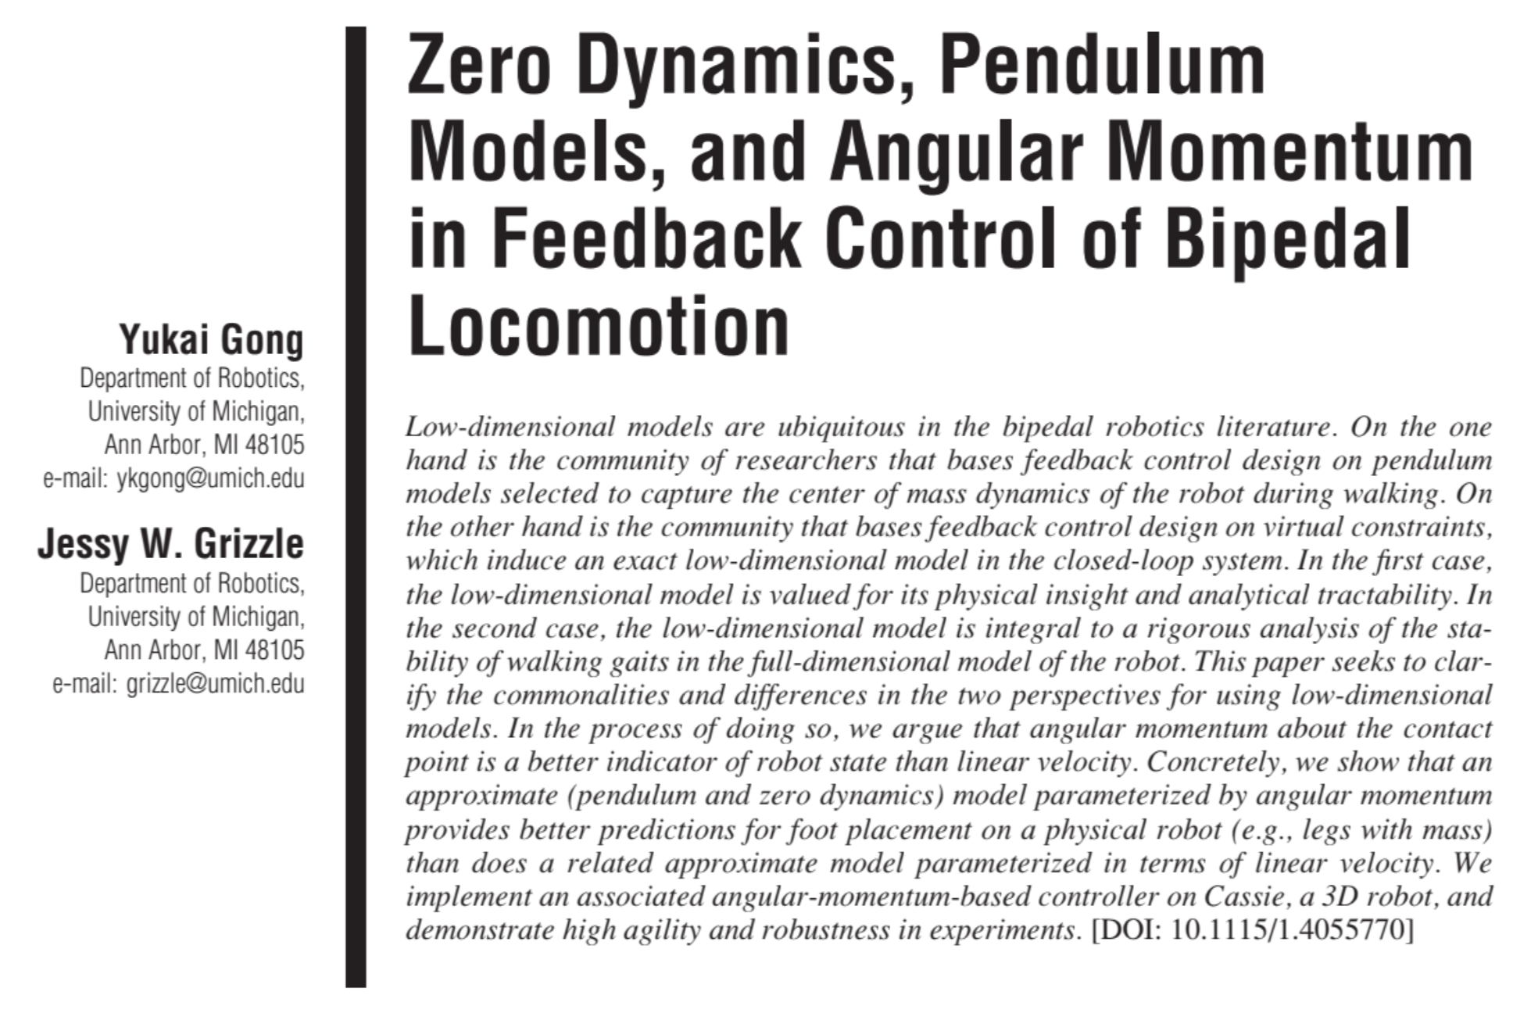
Yukai Gong received a B.S. degree in Naval Architecture and Ocean Engineering in 2015 from the Huazhong University of Science and Technology. He received an M.S.E. in Mechanical Engineering in 2017 and a Ph.D. in Robotics, both from the University of Michigan. He worked on humanoid robots at Figure AI from 2022 to 2023.

Jessy W. Grizzle received a Ph.D. in electrical engineering from The University of Texas at Austin in 1983. He is a Professor of Robotics at the University of Michigan, where he holds the titles of the Elmer Gilbert Distinguished University Professor and the Jerry and Carol Levin Professor of Engineering. He became Director of the Michigan Robotics Institute in July 2016 and stepped down in June 2022 after leading the transformation of the Institute into a formal Department of Robotics in Michigan's College of Engineering.

2023 Nyquist Lecturer

Andrew Alleyne
CSE Dean and Professor
Department of Mechanical Engineering
University of Minnesota

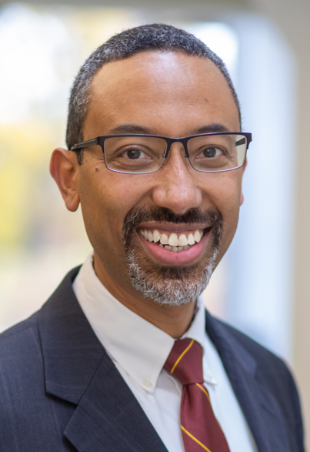
Andrew Alleyne received the B.S. in Mechanical and Aerospace from Princeton University in 1989, and the M.S. and Ph.D. degrees in Mechanical Engineering from the University of California at Berkeley in 1992 and 1994, respectively. He is currently the Dean of the College of Science and Engineering at the University of Minnesota, Twin Cities where he oversees 12 departments and over 8,000 students. He also holds the Russell and Elizabeth Bennett Chair at the University of Minnesota. Prior to that he was a faculty member at the University of Illinois, Urbana-Champaign where he was the inaugural Director for the NSF Engineering Research Center (ERC) on Power Optimization for Electro-Thermal Systems. He is a Fellow of IEEE, ASME and AAAS and is also a member of the U.S. National Academy of Engineering. He was a Fulbright Fellow to the Netherlands where he held a Visiting Professorship at TU Delft. He has also held visiting professorships at the University of Colorado at Boulder, Johannes Kepler University in Austria, and ETHZ in Zurich. His research background encompasses the modeling, simulation, and implementation of control systems for complex systems and nonlinear systems. He has been active in external advisory boards for universities, industry and government including the U.S. Air Force, U.S. Army, U.S. Navy and the Department of Energy. In addition to research and service leadership, he has always had a keen interest in education and earned the UIUC College of Engineering’s Teaching Excellence Award, the UIUC Campus Award for Excellence in Undergraduate Education, and the UIUC Campus Award for Excellence in Graduate Student Mentoring.

2023 Nyquist Lecture
Tuesday October 3 – 11:30-12:30
Event Floor of the Tahoe Blue Event Center, Lake Tahoe, Nevada

A Systems Approach to Modeling, Control, and Design
for Electrified Mobility

Andrew Alleyne
CSE Dean and Professor
Department of Mechanical Engineering
University of Minnesota

We live in an increasingly electrified world. For stationary applications such as industry and manufacturing, this statement has been obvious since the start of the 20th century as steam and belt drives in factories gradually gave way to electric motors for machining, conveyor lines, and all manner of other industrial applications. Now we are seeing a dramatic rise in the electrification of mobility systems. The progress has been steady for several decades but it is really during the past several years that electrified mobility has seen a rapid growth at the level of individual consumer. Interestingly, this growth cuts across widely varying modes of mobility; from individual bicycles to on-highway vehicles to large ships and aircraft.

This talk will detail some of the technical challenges related to Modeling, Control and Design. Of high relevance to systems and controls audiences is the interplay between modes of power distribution within electrified mobility systems. This includes the flow of power, or storage of energy, in the mechanical, chemical, electrical, and thermal domains. For example, power flow in the electrical domain can be constrained by component temperature limits in the thermal domain. Several examples of challenges will be raised along with some solutions for specific problems of Modeling, Control, and Design in electrified mobility. The presented solutions will be integrated such that the chosen modeling tools are specifically amenable to both the control and design challenges. Simulation and experimental results will be presented that demonstrate a superior overall mobility platform performance when a systems approach is taken.

